Name: -Chinthakindi Sree Vardhan Reddy

Sapid: -500093990

Roll no: -R2142210245

Batch: -2 (DevOps-NH)

Lab Exercise 1– Install Terraform on Windows

**Step 1: -**

🡪Browse to the Download Terraform page.

🡪Select the Windows tab under the Operating System heading. The latest version is preselected.

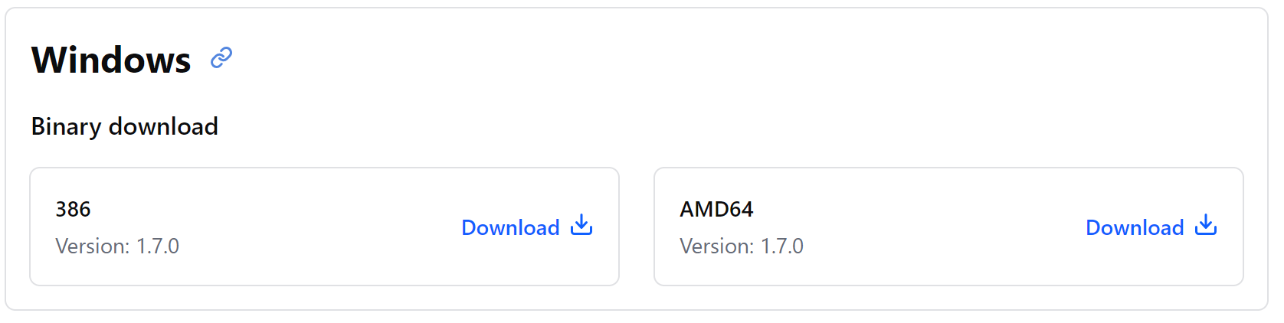

C:\Users\sreev\Downloads\terraform_1.7.0_windows_amd64

🡪We Have to download AMD64 for 64-bit systems.

🡪Unzip the downloaded file. Remember this location so we can add the path to the environment variables.

**Step 2: -** We must Add Terraform Path to System Environment Variables.

🡪Open the start menu, start typing environment and click Edit system environment variables. The System Properties window opens.

🡪Click the Environment Variables button.

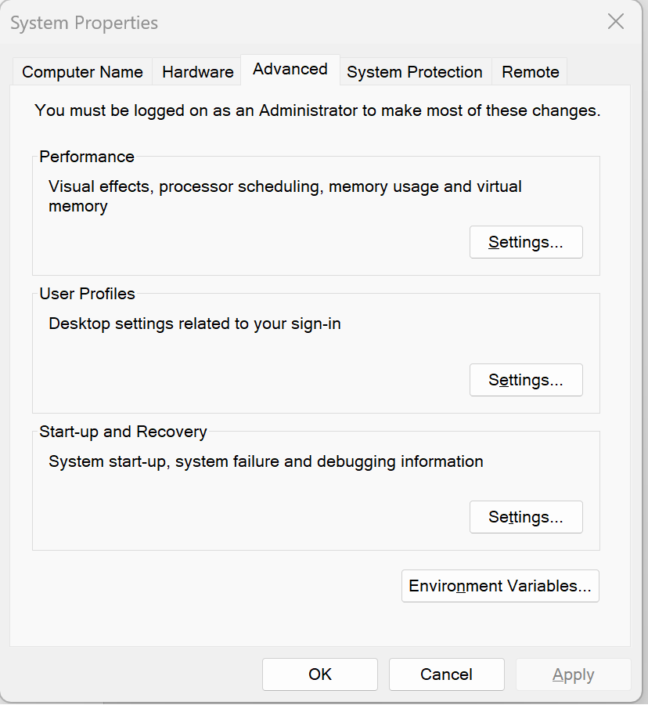

**Step 3: -** Select the Path variable in the System variables section to add terraform for all accounts. And select Path in the User variables section to add terraform for the currently logged-in user only. Click Edit once you select a Path.

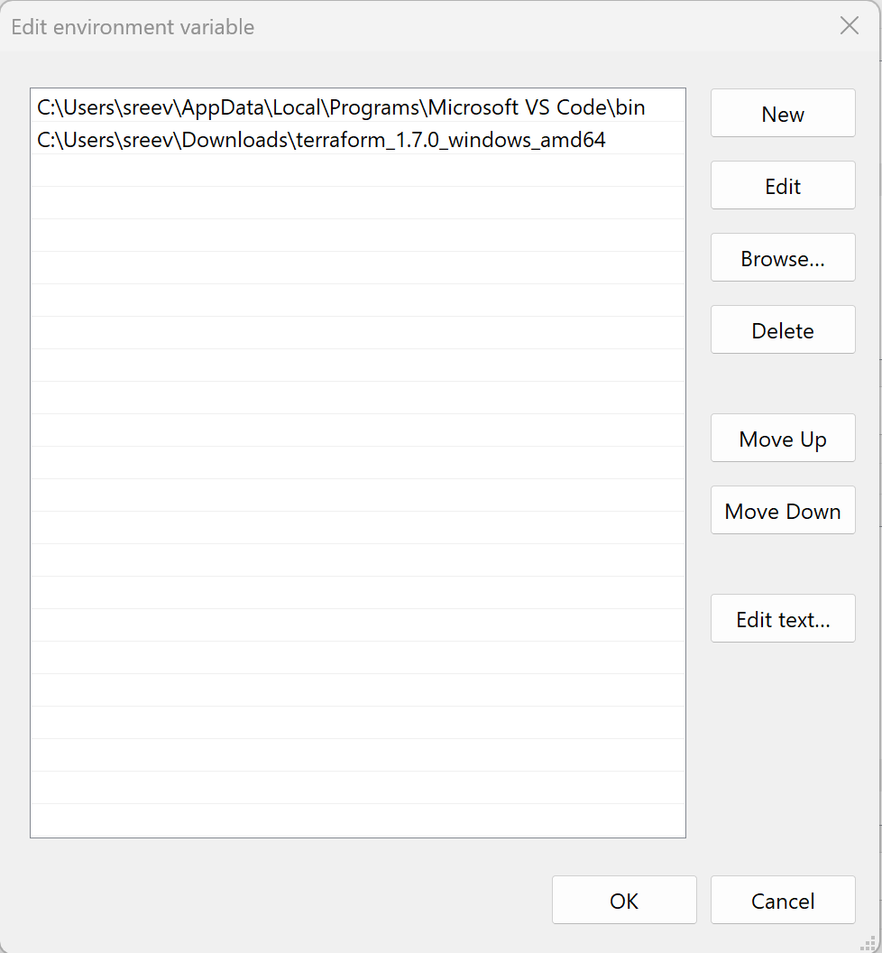

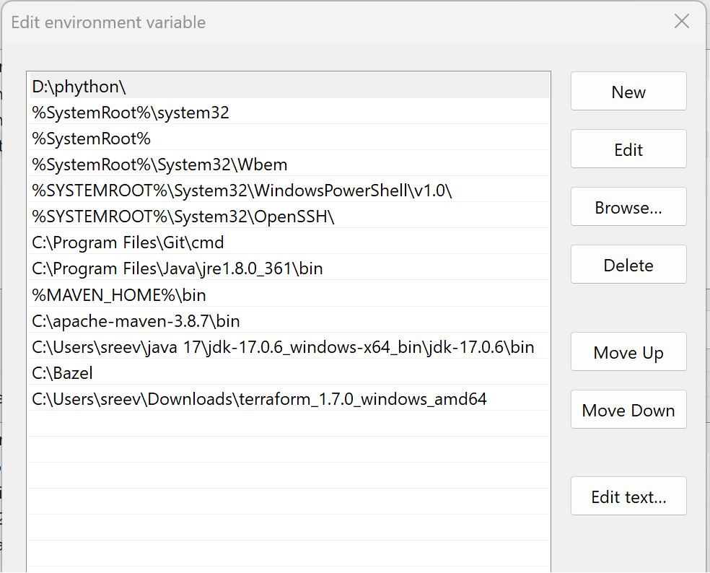

**Step 4: -** Verify Windows Terraform Installation To check the Terraform global path configuration:

🡪Open a new command-prompt window.

🡪Enter the command to check the Terraform version: terraform -version.

